
WMPP DATA PLATFORM
Progress report
From network-drive dependency to governed cloud data
Delivery position as at 11 August 2026
HEADLINE OUTCOME
The supplied semantic model has been repointed away from legacy network/file sources to the Microsoft Fabric Lakehouse SQL endpoint. The Gold dimensional model, Direct Lake serving layer and historical monthly referral snapshots remain active work in progress.

Prepared for | WMPP / project stakeholders
Scope | Data-platform migration, semantic model, Power BI and traceability
Evidence basis | Repository documentation, notebooks, model files and report screenshots
Status convention | Delivered • Built/awaiting Fabric validation • Work in progress • Planned

1. Executive summary
The project has achieved its first major production-readiness milestone: the operational Power BI solution is no longer dependent on a network-drive CSV source. Evidence in the supplied semantic model shows 37 source tables connected to the Fabric Lakehouse SQL endpoint for LH_BCT_WMPP and no remaining network/file-source references.
This is an important source migration, but it is not yet the final target architecture. The current semantic model is composite, using DirectQuery for Lakehouse-connected source tables together with imported derived tables. The intended Gold dimensional model and Direct Lake serving pattern are still being developed.

Delivery position at a glance
Workstream | Status | Evidence-based position
Cloud-source repointing | Delivered | Semantic model points to LH_BCT_WMPP; legacy file/network references removed
Operational Power BI continuity | Delivered | Ten report pages retained; current screenshots supplied
Requirement/KPI traceability | Delivered / reconcile | Traceability page exists; requirement and KPI baselines need formal alignment
Bronze ingestion and controls | Built | Archive, retry, reload and audit framework implemented; Fabric execution gate remains
Silver conformance and DQ | Built | 57-table schema contract and five DQ rules pass local/static validation
Gold dimensional model | Work in progress | Facts, dimensions, KPI logic and serving model are being completed
Historical monthly snapshots | Work in progress | Monthly replay and snapshot logic coded/simulated; production integration pending

MANAGEMENT INTERPRETATION
The platform foundation is credible and the report migration is tangible. The next decision gate should be based on end-to-end Fabric execution, reconciliation, UAT and operability—not on static validation alone.

2. Achievements and evidence

2.1 Report source repointed to governed cloud data
- The supplied semantic model contains no network-drive or file-source references.
- Thirty-seven source tables point to the Fabric Lakehouse SQL endpoint for LH_BCT_WMPP.
- The operational report therefore reads the latest cloud-hosted source data rather than the legacy network-drive CSV path.
- The user-described S3/object-storage landing is part of the cloud ingestion context; the semantic-model evidence specifically confirms its reporting connection to Fabric Lakehouse, not a direct Power BI-to-S3 connection.

2.2 Report continuity preserved
- Ten Power BI report pages have been retained through the source migration.
- Current screenshots demonstrate that operational views—including Active Referrals—remain available while the new dimensional model is built.

2.3 Traceability made visible
- The Power BI solution includes a Requirement Traceability Matrix page.
- The view ties KPI IDs and requirement descriptions to measure names, report pages, status, priority and stakeholder information.
- The supplied screenshot shows 117 KPI IDs, 80 original/reportable requirements and 33 marked complete.

2.4 Controlled ingestion foundation
- The notebook framework includes archive and file-level audit tables, retry/reload controls and resumable processing.
- Ten documented archive-processing issues are recorded as resolved with regression guards.
- Seven notebooks pass JSON and static compilation checks; runtime execution still requires the Fabric Spark/Lakehouse environment.

Source migration in one view
BEFORE  Network-drive CSV | → | NOW  Fabric Lakehouse | → | NEXT  Gold + Direct Lake

3. Power BI evidence

3.1 Active Referrals
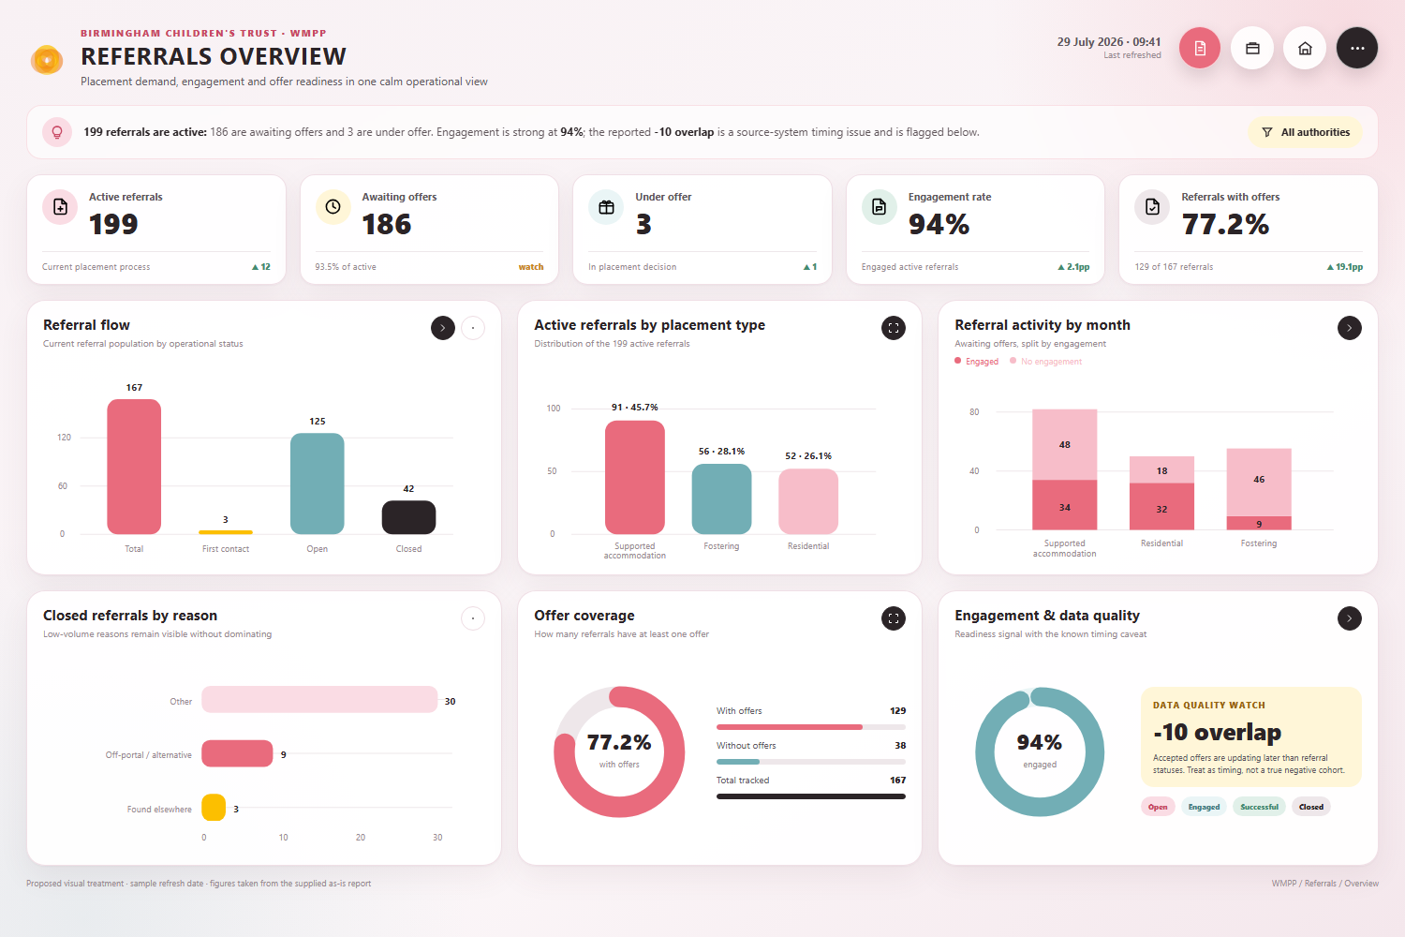
Figure 1. WMPP Referrals Overview using the Pastel Pink v2 visual system.
The screenshot demonstrates continuity of the operational reporting experience after the source migration. It should be treated as evidence of report availability and current-data presentation—not as proof that every target KPI has completed business acceptance.

3.2 Requirement Traceability Matrix
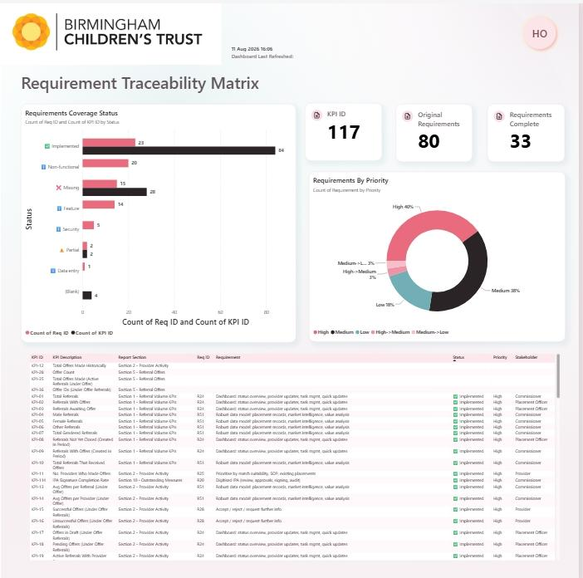
Figure 2. Requirement Traceability Matrix embedded in the Power BI report.

4. Requirements-to-delivery traceability matrix
The matrix below connects the principal requirements and intended outcomes to the evidence found in the repository. Status is deliberately conservative: ‘built’ means implemented in the supplied code and locally/static validated where stated; it does not mean production execution has been proven.
ID | Requirement / outcome | Evidence | Status | Next acceptance gate
R-01 | Remove network-drive dependency | No network/file references in supplied TMDL | Delivered | Observe production refresh and support handover
R-02 | Use governed cloud data source | 37 source tables connect to LH_BCT_WMPP | Delivered | Operational acceptance
R-03 | Preserve operational reporting | Ten pages retained; current screenshots | Delivered | Business regression and UAT
R-04 | Provide requirement/KPI traceability | Power BI traceability page | Delivered / reconcile | Align 87 formal vs 80 reportable requirements
R-05 | Implement Bronze ingestion and audit | Archive/retry/reload notebooks and audit tables | Built | Execute end-to-end in Fabric
R-06 | Implement Silver conformance and DQ | 57-table contract; five DQ rules | Built | Fabric runtime and data reconciliation
R-07 | Implement Gold dimensional model | Target design and notebook chain | Work in progress | Complete facts, dimensions and KPI logic
R-08 | Enable monthly point-in-time reporting | Canonical month logic and snapshot simulation | Work in progress | Historical replay and report integration
R-09 | Use Direct Lake semantic serving | Defined in target architecture | Planned | Repoint from current composite model
R-10 | Complete security, performance and handover | SOW acceptance criteria | Not yet evidenced | RLS, performance, UAT and runbook sign-off

Traceability governance decisions
- Confirm whether the signed requirement baseline is 87 formal requirements or the 80 reportable requirements shown in the current Power BI traceability page.
- Reconcile the 117 target KPI count with the 140 measure declarations in the supplied semantic model. Measures and KPIs are not automatically equivalent.
- Preserve evidence links from every accepted requirement to its data source, transformation, semantic measure, report visual and test result.

5. Bronze, Silver and Gold delivery

5.1 Bronze — ingestion and operational control
- Resumable ZIP and file ingestion is implemented with pipeline, archive, file and table-level audit records.
- Idempotent retry/reload controls reduce the risk of duplicate or partial archive processing.
- Runtime success, scale and supportability must still be demonstrated in the target Fabric workspace.

5.2 Silver — schema conformance and data quality
- The current validation pack defines a 57-table schema contract with one export date per table.
- Five data-quality rules are catalogued and pass local/static checks.
- Updated schema piping, business-rule execution and source-to-Silver reconciliation remain acceptance gates.

5.3 Gold — dimensional serving layer
- The target architecture defines governed facts, conformed dimensions and a semantic serving layer aligned to Power BI.
- Gold dimensional modelling, KPI implementation and final semantic-model repointing are active work in progress.
- The final serving target is Direct Lake; the current supplied model is composite and should not be described as Direct Lake-complete.
Layer | Current capability | Current status | Definition of done
Bronze | Archive ingestion, audit, retry/reload | Built; Fabric test gate | Successful repeatable run with complete audit trail
Silver | 57-table conformance and five DQ rules | Statically validated | Live load, reconciliation and DQ exception handling
Gold | Facts, dimensions, KPIs and semantic serving | Work in progress | Business reconciliation, Direct Lake and UAT

CRITICAL DISTINCTION
The notebook chain is well structured and passes local/static validation. The repository itself states that Bronze → Silver → Gold must still be executed end-to-end inside Microsoft Fabric, including a separate historical replay test.

6. Historical monthly referral snapshots
Historical point-in-time reporting is the next major user-facing capability. It will preserve the referral position at each month end so users can analyse how workload, backlog, offers and outcomes changed over time rather than seeing only the latest state.

Designed processing pattern
Step | Capability | Purpose
1 | Replay historical archives | Use resumable archive processing to select the canonical export for each month.
2 | Rebuild month-specific Silver | Apply the schema and business rules against each historical month.
3 | Write Gold snapshots | Persist an AS_OF_DATE grain in gold.fact_referral_snapshot.
4 | Reconcile | Compare monthly counts and exceptions to the source and audit metrics.
5 | Expose in Power BI | Add point-in-time trends and period comparison to the report.

Current evidence and remaining work
- Monthly canonical-export selection and Gold snapshot orchestration are documented in the archive batch process.
- A local simulation exercises three month-end dates against gold.fact_referral_snapshot.
- Production historical replay, business reconciliation and Power BI integration are not yet evidenced and remain work in progress.
EXPECTED BUSINESS VALUE
The snapshot layer will allow management to answer: ‘What did the referral position look like at the end of each month?’—including later changes that would otherwise overwrite the historical view.

Acceptance criteria for the snapshot release
- Every historical month has one identified canonical export and an auditable processing status.
- Snapshot counts reconcile to source exports within agreed tolerance.
- Reloading a month is idempotent and does not duplicate facts.
- Late-arriving corrections are governed and their effect on prior snapshots is explicit.
- Power BI filters and trends use AS_OF_DATE consistently and pass business UAT.

7. Decisions, risks and next steps

Decisions required
Decision | Required resolution
Requirement baseline | Choose and approve 87 formal vs 80 reportable requirements; document exclusions/merges.
KPI baseline | Reconcile 117 target KPIs with current semantic-model measures and retire duplicates/technical measures from business counts.
Serving pattern | Confirm the cutover criterion from the current composite model to Gold/Direct Lake.
Historical policy | Agree canonical-month, late-arrival and restatement rules for point-in-time reporting.

Principal delivery risks
Risk | Rating | Control
Static checks mistaken for production proof | High | Run the full chain in Fabric and retain execution evidence.
Requirement/KPI count ambiguity | High | Approve one baseline and trace every item to tests and visuals.
Gold model changes report outputs | Medium | Parallel reconciliation and page-level regression testing.
Historical replay creates duplicates or gaps | Medium | Idempotency tests, canonical-file rules and audit reconciliation.
Network source retired too early | Medium | Decommission only after UAT, operability and cutover acceptance.

Recommended next steps
- Run the seven-notebook Bronze → Silver → Gold chain end-to-end in the target Fabric workspace and retain audit outputs.
- Complete source-to-Silver and Silver-to-Gold reconciliation, including data-quality exceptions.
- Approve the requirement and KPI baselines, then update the Power BI traceability matrix.
- Complete the Gold star schema and repoint the semantic model from the current latest-state/composite model.
- Execute historical monthly replay, validate gold.fact_referral_snapshot and add point-in-time report pages.
- Complete RLS, performance testing, UAT, support runbook and cutover/decommission approvals.

8. Evidence register
This report is based on the repository materials reviewed on 11 August 2026. The register below identifies the principal evidence sources used to assign status.
Evidence | Repository item | Used for
As-is assessment | 02_As_Is_Assessment_Report.md | Legacy network-drive dependency, requirements and reporting gaps
Gap analysis | 03_Gap_Analysis_Report.md | Architecture gaps and phased delivery plan
Target architecture | 04_Proposed_Solution_Architecture.md | Bronze/Silver/Gold and Direct Lake target
Statement of Work | 06_Statement_of_Work.md | Deliverables and acceptance criteria
Semantic changelog | 07_Semantic_Model_Changelog_v00_to_v01.md | Measure/report-page changes and baseline caveats
Semantic model | SM Test v2.zip | Current Fabric endpoint, table modes, measures and relationships
Progress document | fabrics data solution.docx | Archive/audit/Silver progress and backlog
Notebook validation | notebooks/version 02 04/VALIDATION.md | Static checks and explicit Fabric runtime dependency
Archive process | notebooks/version 02 04/ARCHIVE_BATCH_PROCESS.md | Audit, replay, monthly canonical export and snapshot design
Issue log | notebooks/version 02 04/issue_log.md | Ten resolved archive-processing issues and regression guards
Power BI screenshots | Power BI screenshots/ | Operational report and traceability-page evidence
Visual design system | WMPP Pastel Pink v2 theme and previews | Colour, typography and visual-treatment alignment

Repository links
https://github.com/NewRay99/fabric-csv-bronze-ingestion/tree/master/project%20X/client%20documentation
https://github.com/NewRay99/fabric-csv-bronze-ingestion/blob/master/project%20X/client%20documentation/SM%20Test%20v2.zip
https://github.com/NewRay99/fabric-csv-bronze-ingestion/blob/master/project%20X/client%20documentation/fabrics%20data%20solution.docx
https://github.com/NewRay99/fabric-csv-bronze-ingestion/tree/master/project%20X/client%20documentation/notebooks
https://github.com/NewRay99/fabric-csv-bronze-ingestion/tree/master/project%20X/client%20documentation/Power%20BI%20screenshots

